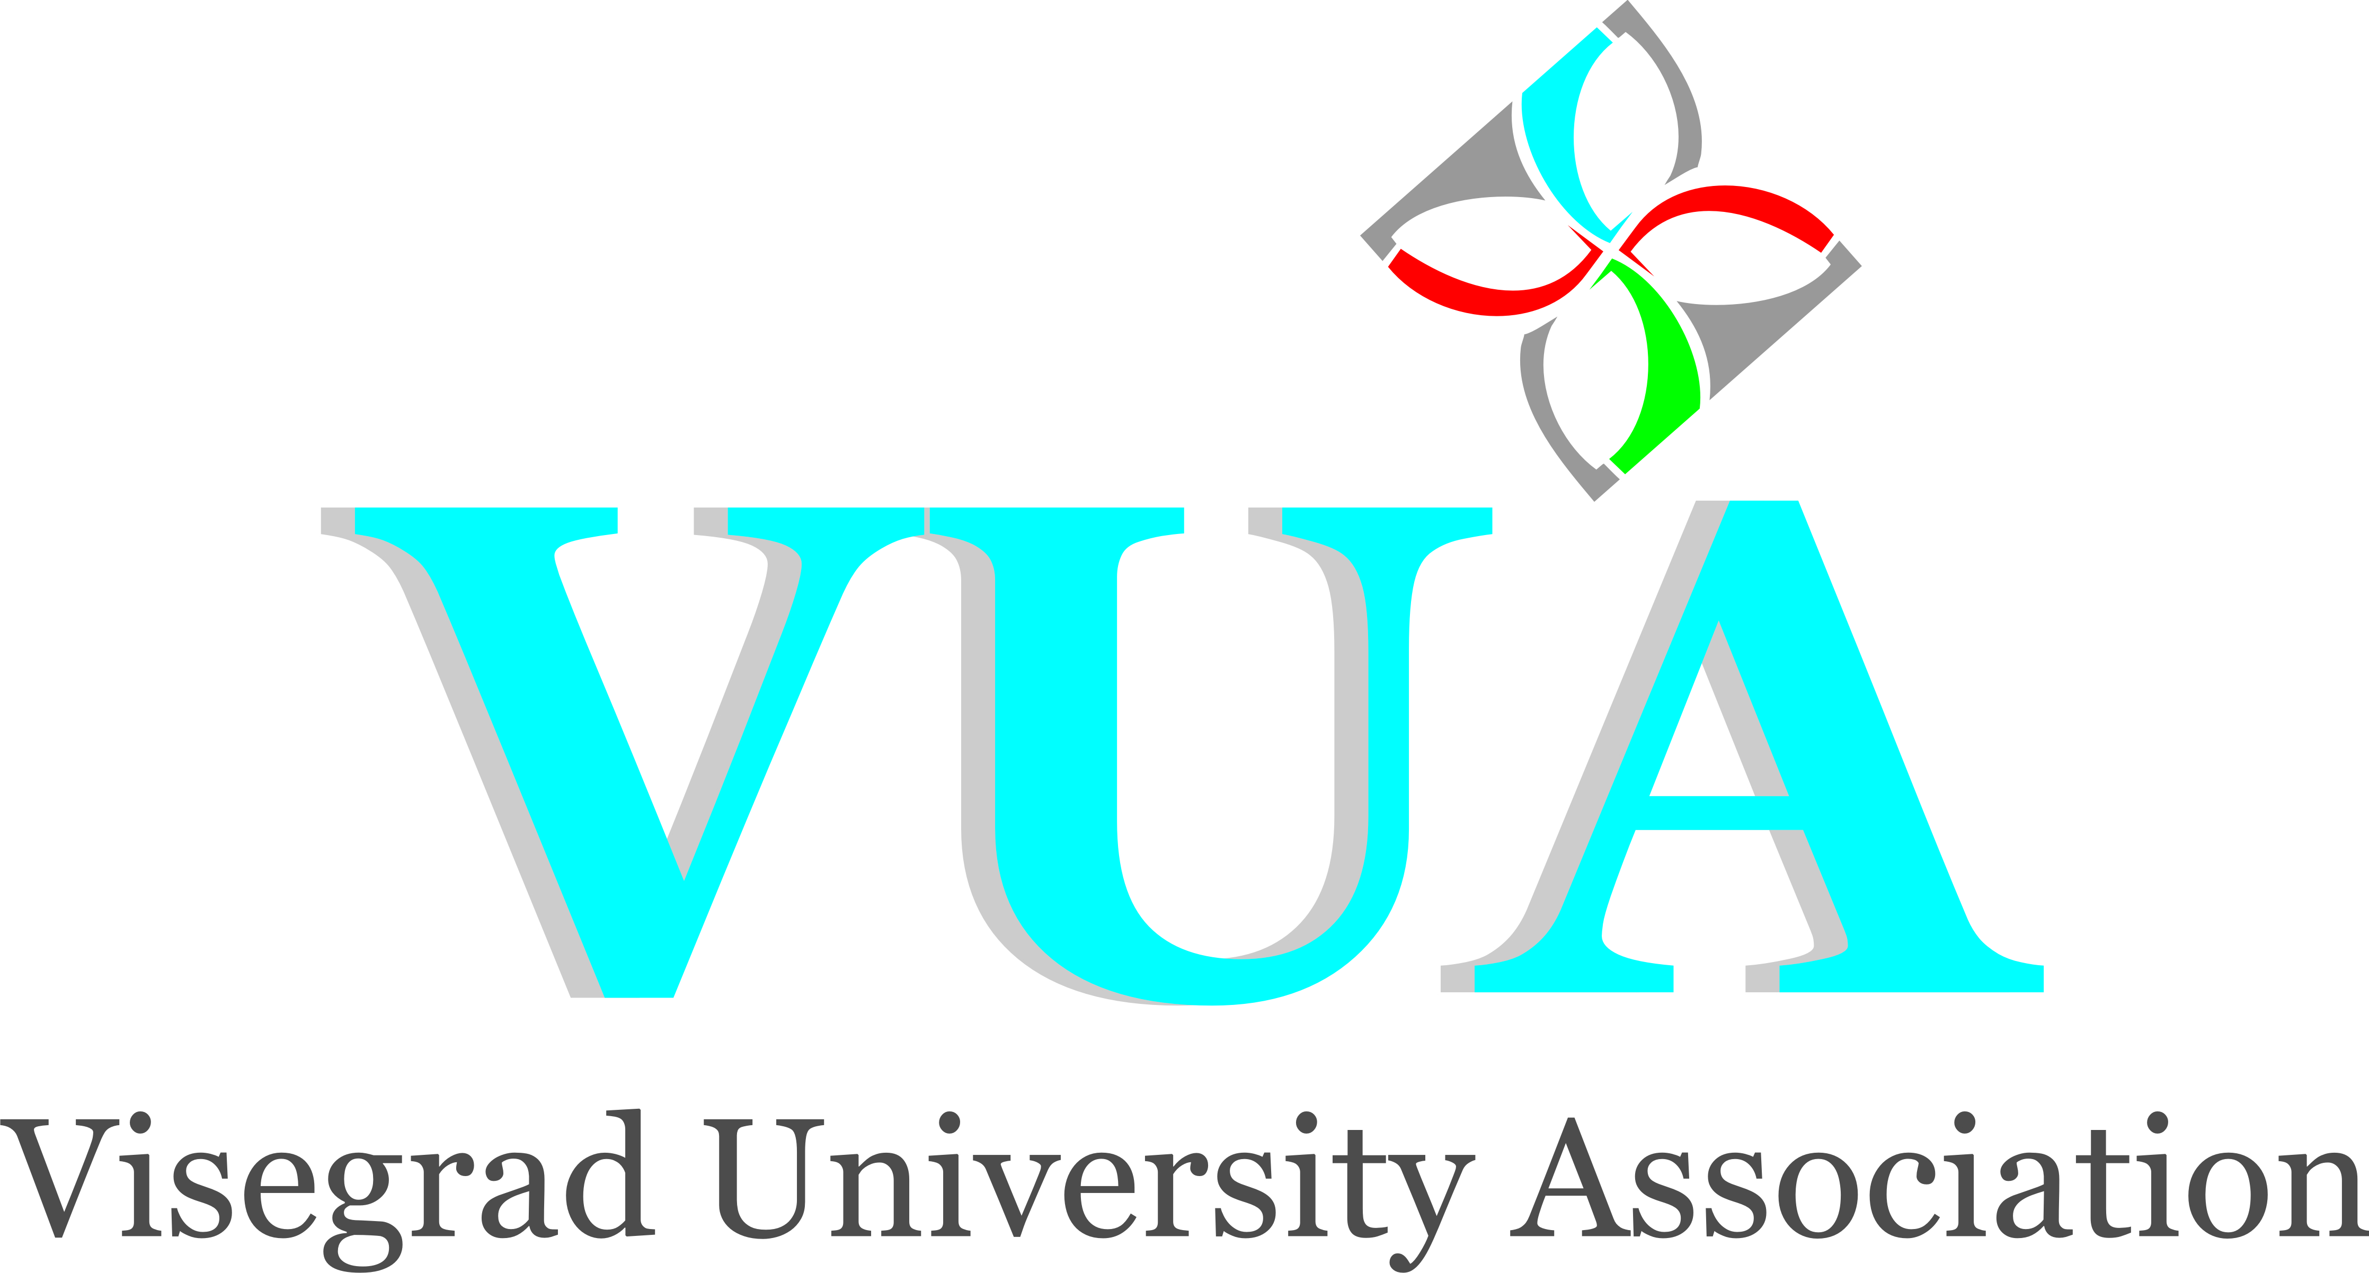



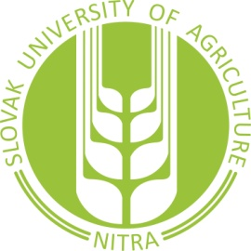

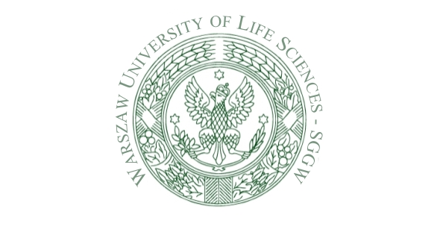

INVITATION

VISEGRAD UNIVERSITY ASSOCIATION
WARSZAW UNIVERSITY OF LIFE SCIENCES
and
SLOVAK UNIVERSITY OF AGRICULTURE in Nitra

invite you to the international scientific symposium

Sustainable Development and Agribusiness

that will take place at the Warsaw University of Life Sciences-SGWW, Poland

on December 6, 2012

as a part of the strategic project of the International Visegrad Fund
Sustainability in Agrisector of V4 Coutries and Cooperating Regions

Topics of interest:

- Sustainable Development & Resource Management
- Methodologies for Measuring Sustainability in the Food System
- Economic Valuation of New Technologies and Institutional Innovations for Improving Sustainability in Agribusiness.
- Impact Assessment of New Sustainable Food Chains, New Technologies and Governance Structures.
- The Role of Policy Measures in ensuring sustainability of agribusiness sector.
- Main Dimensions of change of the CAP and its implications for the sustainability of agribusiness.
- Growth & Innovation & Agribusiness
- All other issues related to aspects of sustainability (social, cultural, environmental, economic)

Deadline for full papers is October 15, 2012. Papers and applications are to be sent to kepg_konferencja@sggw.pl
as well as vladislav.valach@uniag.sk.

We will notify all authors whose papers will be accepted
till Oct 20, 2012.

The accepted articles will be published in Scientific Annals of Agricultural Economics and Rural Development (Roczniki Naukowe Ekomomii Rolnictwa i Rozwoju Obszarów
Wiejskich), a monograph Sustainable development and Agribusiness as well as the Visegrad Journal on Bioeconomy and Sustainable Development providing the authors will take part in the conference.

For comprehensive information on deadlines, registration fee, venue and programme please visit http://keipg.wne.sggw.pl/en/conferences/
Registration fee 175 EUR with publication, 75 EUR without publication

Program committee:
Peter Bielik, Slovak University of Agriculture in Nitra, Slovak Republic
Alojzy Szymański, Warsaw University of Life Sciences, Poland
Bogdan Klepacki, Warsaw University of Life Sciences, Poland
Włodzimierz Sady, Agricultural University in Cracow, Poland
Jaroslav Hlušek, Mendel University in Brno, Czech Republic
Lászlo Villányi, Szent Istvan University in Gödöllő, Hungary
Victor Efimov, Saint-Petersburg State Agrarian University, Russian Federation
Dmitro Melnyczuk, National University of Life and Environmental Sciences, Ukraine
Wim Heijman, Wageningen University, Netherlands
Alina Daniłowska, Warsaw University of Life Sciences, Poland
Elena Horska, Slovak University of Agriculture in Nitra, Slovak Republic

Organizing committee:
Agata Malak-Rawlikowska, Warsaw University of Life Sciences, Poland
Grzegorz Sobiecki, Warsaw University of Life Sciences, Poland
Vladislav Valach, Slovak University of Agriculture in Nitra
Georgetta Palsova, Slovak University of Agriculture in Nitra

